**ASSIGNMENT 7**

**JAVASCRIPT**

**If mouse button is pressed background colour should be red.**

**If mouse button is released then background colour should be yellow**

<html>

<head>

<script type="text/javascript" charset="utf-8">

function mouseDown(){

document.body.style.backgroundColor = "red";

}

function mouseUp(){

document.body.style.backgroundColor = "yellow";

}

</script>

</head>

<body>

<h1 onmousedown="mouseDown()" onmouseup="mouseUp()">Click the Text</h1>

</body>

</html>

**Output**

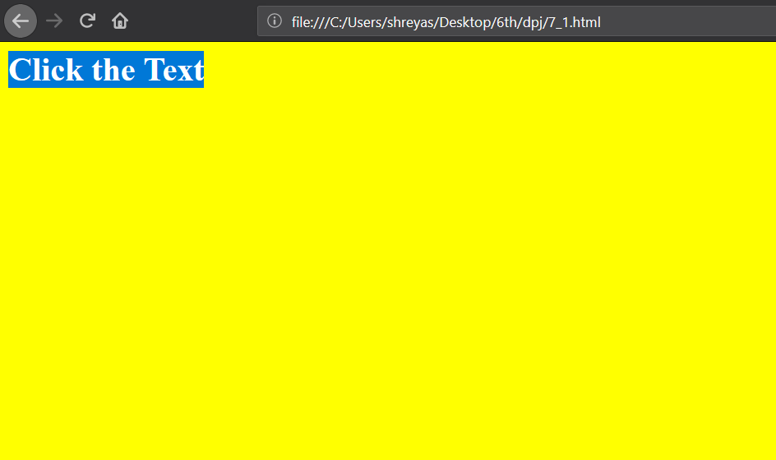

**Write using javascript which mouse button is clicked**

<html>

<body>

<div onmousedown="WhichButton(event)">Click this text with one of your mouse buttons to return a number.

<p>

0 = The left mouse button<br>

1 = The middle mouse button<br>

2 = The right mouse button

</p>

</div>

<script>

function WhichButton(event) {

alert("You pressed button: " + event.button)

}

</script>

</body>

</html>

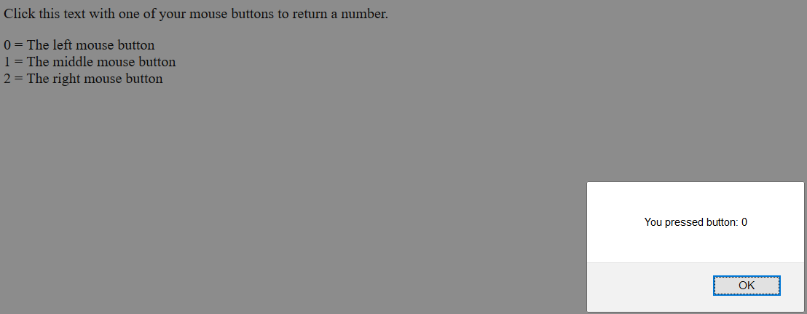

**Write a javascript that handle below event**

1. **If mouse is over the heading it should yellow and mouse is out it should be black**
2. **If find time button is clicked current date and time is showed**
3. **If red button is clicked background should red and same as green**

<html>

<head></head>

<body onunload="unload()">

<h1 onmouseover="yellow()" onmouseout="black()" id="h1">hello</h1>

<button onclick="time()">Find Time</button>

<button onclick="red()">Red</button>

<button onclick="green()">Green</button>

<script type="text/javascript">

function yellow() {

document.getElementById("h1").style.color="yellow";

}

function black() {

document.getElementById("h1").style.color="black";

}

function time(){

ttime = new Date();

alert(ttime.toString());

}

function red(argument) {

document.body.style.background="red";

}

function green(argument) {

document.body.style.background="green";

}

function unload(argument) {

alert("byyy");

}

</script>

</body>

</html>

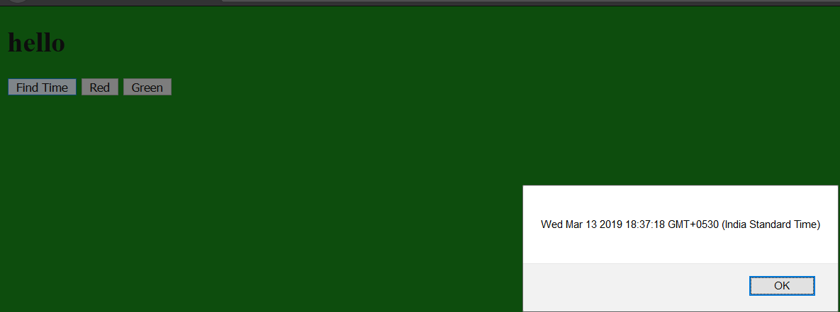

**Write a javascript that handle below event**

1. **Display key code for key pressed in keyboard**
2. **If the key pressed is a,e,i,o,u then alert says vowel is pressed**
3. **When key is released background should change to blue for input element**

<html>

<head>

<title></title>

</head>

<body>

<input type="text" id="name" onkeypress="check(event)" onkeyup="change(event)">

<p id="p"></p>

<script>

function check(event) {

document.getElementById("name").style.background="white";

var x = event.which || event.keyCode;

document.getElementById("p").innerHTML=x;

if(x==97 | x==101 | x==105 | x==111 | x==117)

alert("Vowel is pressed...");

}

function change(event) {

document.getElementById("name").style.background="blue";

}

</script>

</body>

</html>

